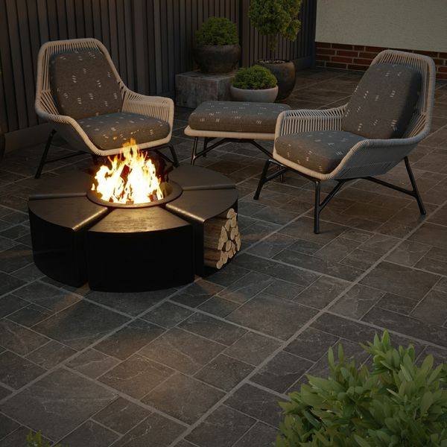**Witton Noir Porcelain Paving Slabs:**

## **Product Description**

Featuring all the characteristics of a natural stone modular pattern in a durable porcelain body, Witton Noir 20mm Porcelain Slab Tiles encapsulate a traditional multi-size pattern within the tile surface, giving an easy option for creating, what is traditionally achieved by mixing several different sized individual tiles together. Witton retains the antiqued rustic charm that's so renowned in old traditional stone floors.

Have you tried our [20mm Paving Slab Trims](https://www.wallsandfloors.co.uk/20mm-paving-slab-trims)?

**What's special about these tiles?**

> Cool, charcoal tone

> Weathered edge for aged charm

> On-trend stone effect modular design

> Ultra durable, weather-resistant 20mm porcelain body

> Strong R11 anti-slip surface, perfect for outdoor spaces

**Try before you buy**

If you'd like to take a closer look, why not order a sample tile? Samples are a great way to get a feel for a tile's true colour and texture, and you can see how it looks in your chosen room!

**Have you seen our selection of**[**Norcros Rock-Tite products**](https://www.wallsandfloors.co.uk/rock-tite-outdoor-installation)**? They're perfect for fixing and completing outdoor projects!**

## **Product INFO**

* Product ID: 44827
* Tiles Per SQM: 2.8246592754749
* Sale by: Per SQM
* Size: 595x595x20mm
* Weight: 13.80 KG
* Material Type: Porcelain
* Finish: Matt
* Colour: Grey
* Suitability: Floors
* Area Of Usage: External
* Grade: 4
* Rectified Edge: Yes
* Underfloor Heating: Yes
* Anti Slip Grade: R11 / 35 Degrees
* Document: [20mm Installation Guide](https://m2.wallsandfloors.co.uk/media/amasty/amfile/attach/20mm-installation-guide_4.pdf),[Cleaning and Protection Guide](https://m2.wallsandfloors.co.uk/media/amasty/amfile/attach/ltp_-_walls_floors_-_external_porcelain_-_cleaning_and_protection_guide_-_april_2020.pdf)
* Thickness (mm): 20